 | COMMONWEALTH OF PENNSYLVANIA  PENNSYLVANIA PUBLIC UTILITY COMMISSION  COMMONWEALTH KEYSTONE BUILDING  400 NORTH STREET  HARRISBURG, PENNSYLVANIA 17120 | IN REPLY PLEASE REFER TO OUR FILE

July 1, 2022

A-2020-3020667

ERIC WHITE, ASSISTANT COUNSEL
COMMONWEALTH OF PENNSYLVANIA
DEPARTMENT OF TRANSPORTATION
OFFICE OF CHIEF COUNSEL
REAL PROPERTY DIVISION
P.O. BOX 8212
HARRISBURG, PA 17105-8212
Email: ewwhite@pa.gov

Dear Sir:

Receipt is acknowledged of your letter deemed Petition for Reconsideration and/or Clarification of the Opinion and Order of the Public Utility Commission Issued June 16, 2022 from Commonwealth of Pennsylvania, Department of Transportation, dated July 1, 2022, and received in this Office on July 1, 2022. The Commission’s Rules of Administrative Practice and Procedure, set forth in Title 52 PA Code §1.36(a), require that such a Petition for Reconsideration and/or Clarification and shall be personally verified or notarized by a party or by an authorized officer of the party if it is a corporation or an association.

No verification or affidavit was attached to your Petition for Reconsideration and/or Clarification and accordingly it can not be accepted for filing.

Enclosed please find forms and information with respect to verification, which must be completed and filed with this Office.

We will hold your filing for 15 days from the date of this letter. If the verification and/or notarization is not received by that date it will be returned to you as unfiled, pursuant to 52 PA Code §1.4(d).

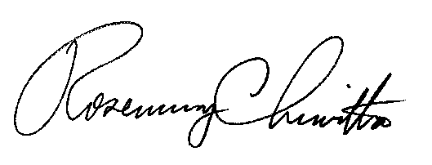
Sincerely,

Rosemary Chiavetta
Secretary

Enclosure

RC:AEL

§1.36 Verification.

(a) Applications, petitions, formal complaints, motions and answers thereto containing an averment of fact not appearing of record in the action or containing a denial of fact shall be personally verified by a party thereto or by an authorized officer of the party if a corporation or association. Verification means a signed written statement of fact supported by oath or affirmation or made subject to the penalties of 18 Pa. C.S. §4904 (relating to unsworn falsification to authorities). If verification is required, notarization is not necessary.

A-2020-3020667

§1.36 Verification.

Verification
_________

I, _______________________________, hereby state that the facts above set forth are true and correct (or are true and correct to the best of my knowledge, information and belief), and that I expect to be able to prove the same at a hearing held in this matter. I understand that the statements herein are made subject to the penalties of 18 Pa. C.S. § 4904 (relating to unsworn falsification to authorities).

________________ _____________________________________
Date Signature

