 | COMMONWEALTH OF PENNSYLVANIA  PENNSYLVANIA PUBLIC UTILITY COMMISSION  COMMONWEALTH KEYSTONE BUILDING  400 NORTH STREET  HARRISBURG, PENNSYLVANIA 17120 | IN REPLY PLEASE REFER TO OUR FILE

July 7, 2022

PETER MCCAWLEY CONSULTANT
PROGRESSIVE LIGHT & POWER LLC
3427 CLARENDON PL
THOUSAND OAKS CA 91360
PETEM@HYPERTRACK.US

Dear Mr. McCawley:

On June 17, 2022, the Commission received the Application of Progressive Light & Power, LLC. for approval to supply natural gas services to the public in the Commonwealth of PA. Upon initial review, the Application has been determined to be deficient for the following reasons:

- No Tax Certification Form

Pursuant to 52 Pa. Code §1.4, you are being advised of these deficiencies and are required to file corrections. Failure to correct the foregoing deficiencies within 20 days of the date of this letter will result in the Application being returned unfiled.
Please return your items to the above listed address and address to the attention of the Office of the Secretary. Or, you may e-mail the document to amclouser@pa.gov.
If you have any question in regards to this letter, please contact our bureau at (717) 772-7777. Thank you
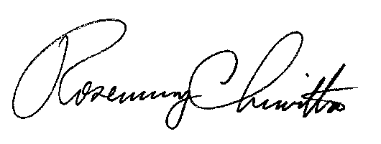
Sincerely,

Rosemary Chiavetta
Secretary

RC:anc

