 | COMMONWEALTH OF PENNSYLVANIA  PENNSYLVANIA PUBLIC UTILITY COMMISSION  COMMONWEALTH KEYSTONE BUILDING  400 NORTH STREET  HARRISBURG, PENNSYLVANIA 17120 | IN REPLY PLEASE REFER TO OUR FILE

IN REPLY PLEASE
REFER TO OUR FILE
Secretary
717-772-7777
August 4, 2022

Service by Email

A-2022-3034261

JENNEDY S. JOHNSON, ASSISTANT GENERAL COUNSEL
PECO ENERGY COMPANY
2301 MARKET STREET/S23-1
PHILADELPHIA, PA 19103
Email: Jennedy.Johnson@exeloncorp.com

Dear Ms. Johnson:

Receipt is acknowledged of the Letter of Notification of PECO Energy Company, which has been captioned and docketed to the above number.

This matter will receive the attention of the Commission and you will be advised of any further necessary procedure.

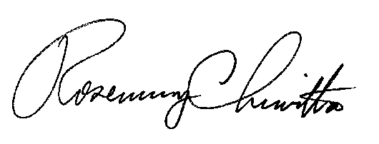
Sincerely,

Rosemary Chiavetta
Secretary

RC:AEL

