 | COMMONWEALTH OF PENNSYLVANIA  PENNSYLVANIA PUBLIC UTILITY COMMISSION  COMMONWEALTH KEYSTONE BUILDING  Office of Administrative Law Judge  400 NORTH STREET  HARRISBURG, PENNSYLVANIA 17120
August 9, 2022

In Re: F-2022-3032700

(SEE ATTACHED LIST)

Rachel Hiles v. PPL Electric Utilities Corporation

Appeal of BCS Decision - Billing Dispute/Payment Arrangements

Cancellation Notice

This is to inform you that a hearing by telephone on the above-captioned case has been cancelled:

Type: Initial Call-In Telephonic Hearing

Date: Wednesday August 17, 2022

Time: 10:00 A.M.

Presiding: Administrative Law Judge Marta Guhl
Phone: 215.560.2105 Fax: 215.560.3133

Please mark your records accordingly.

F-2022-3032700 - RACHEL HILES v. PPL ELECTRIC UTILITIES CORPORATION
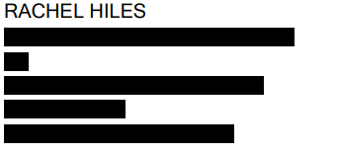
KIMBERLY A KLOCK ESQUIRE
MICHAEL J SHAFER ATTORNEY
PPL SERVICES CORP
TWO NORTH 9TH STREET GENTW3
ALLENTOWN PA 18101
610.774.5696
610.774.2599
kklock@pplweb.com
mjshafer@pplweb.com
Accepts eService
DEVIN T RYAN ESQUIRE
LINDSAY A BERKSTRESSER ESQUIRE
POST AND SCHELL PC
17 NORTH 2ND STREET
12TH FLOOR
HARRISBURG PA 17101-1601
717.612.6021
717.731.1970
dryan@postschell.com
lberkstresser@postschell.com
Accepts eService
Represent PPL Electric Utilities Corporation

