BEFORE THE
PENNSYLVANIA PUBLIC UTILITY COMMISSION

Wuxin Yang :
: C-2022-3030596
v. :
:
Peoples Gas Company LLC :

SECOND INTERIM ORDER
CLOSING THE RECORD

AND NOW, (1) the evidentiary hearing in this proceeding have been held on April 20, 2022; (2) the Parties having been directed at the evidentiary hearing to file a memorandum in support of their respective position in this proceeding by June 17, 2022 (Hearing Transcript pp. 92-93); (3) the hearing transcript having been filed with the Secretary’s Bureau on May 26, 2022; (4) the First Interim Order having been entered on June 22, 2022, directing the Parties to file a memorandum in support of their position by July 22, 2022; and neither Party having filed a memorandum in support of their position by July 22, 2022,

THEREFORE,

IT IS ORDERED:

- That the record at Docket No. C-2022-3030596 is hereby closed.

- That the Initial Decision in this case shall be prepared and issued.
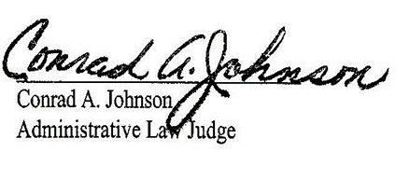

Date: August 9, 2022

C-2022-3030596 - WUXIN YANG V. PEOPLES GAS COMPANY LLC
WUXIN YANG
1014 MIRROR ST
PITTSBURGH PA 15217
412.961.5905
YANGWUXIN413@GMAIL.COM
JENNIFER PETRISEK ESQUIRE
PEOPLES GAS COMPANY LLC
375 NORTH SHORE DRIVE
PITTSBURGH PA 15212
412.208.6834
Accepts eService

