BEFORE THE
PENNSYLVANIA PUBLIC UTILITY COMMISSION

Conyngham Township :
:
v. : C-2021-3023624
:
Sanitary Sewer Authority :
of the Borough of Shickshinny :

EIGHT INTERIM ORDER
REESTABLISHING LITIGATION SCHEDULE

Background

This case has an extended procedural history: numerous continuances have been granted, prehearing conferences have been held, and the evidentiary hearing has been postponed several times. On August 19, 2022, a fourth prehearing conference convened in this proceeding to reestablish the litigation schedule. Respective counsel for Conyngham Township (Township), the Sanitary Sewer Authority of the Borough of Shickshinny (SSABS), and the Commission’s Bureau of Investigation and Enforcement (I&E) participated in the conference.

Reestablished Litigation Schedule

This Order confirms the reestablished litigation schedule discussed during the fourth prehearing conference. The litigation schedule will be as follows:

Date | Event
September 1, 2022 | SSABS’s Written Direct Testimony and SSABS’s Rebuttal Testimony to the Written Direct Testimony of the Township and I&E - Due
September 16, 2022 | The Township’s and I&E’s Rebuttal Testimony to SSABS’s Written Direct Testimony - Due
September 30, 2022 | Stipulations - Due
October 4, 2022 | Telephonic Evidentiary Hearing Starting at 10:00 a.m.
TBD at Hearing | Briefing Schedule

Electronic Service

The documents described in the litigation schedule referenced above shall be served electronically on the date indicated, by 4:00 p.m. The email address for ALJ Johnson is cojohnson@pa.gov.

You must also email ALJ Johnson’s Legal Assistant Nicholas Miskanic at nmiskanic@pa.gov a copy of any documents that you electronically file with the Secretary’s Bureau in this proceeding. If you email Legal Assistant Miskanic any documents or correspondence, you must also send a copy to all parties in this case. The current Service List (with available email addresses) is attached to this Order. Accordingly, all parties are encouraged to sign-up for efiling and eservice. Please visit the Commission’s website at www.puc.pa.gov for instructions.

If you intend to present any documents for my consideration, you must email them to Legal Assistant Miskanic at nmiskanic@pa.gov. You must also submit a copy of each document you submit to me to all parties in this case. As previously noted, a copy of the Commission’s current service list of all parties (with available email addresses) is attached to this Order.

If you are unable to scan and email your documents, please email Legal Assistant Miskanic for possible alternative arrangements.

Briefs

The Parties must comply with 52 Pa.Code §§ 5.501, et seq., regarding the
preparation and filing of briefs. Main Briefs shall be limited to 60 pages and Reply Briefs shall
be limited to 40 pages. The electronic version of a brief must be prepared in Microsoft Word.

Discovery

Discovery is closed.

Prior Interim Orders

Prior interim orders remain in effect to the extent that the prior interim orders are not inconsistent with this Eighth Interim Order.
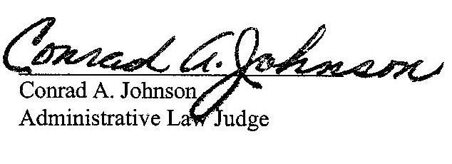

Date: August 25, 2022

Pennsylvania Public Utility Commission Office of Administrative Law Judge Piatt Place, Suite 220 301 Fifth Avenue Pittsburgh, PA 15222 Telephone: (412) 565-3550 Fax: (412) 565-5692
cojohnson@pa.gov

C-2021-3023624 - CONYNGHAM TOWNSHIP v. SANITARY SEWER AUTHORITY OF THE BOROUGH OF SHICKSHINNY
VITO J DELUCA ATTORNEY
DELUCA LAW OFFICES
26 PIERCE STREET
KINGSTON PA 18704
570.288.8000
Accepts e-Service
Representing Conyngham Township
SEAN W LOGSDON ESQUIRE
85 DRASHER ROAD
DRUMS PA 18222
570.788.6647
Accepts e-Service
Representing Sanitary Sewer Authority of The Borough of Shickshinny SANITARY

SEWER AUTHORITY OF THE BOROUGH OF SHICKSHINNY
1 MAIN RD
SHICKSHINNY PA 18655
SHICKAUTH@FRONTIER.COM
Via electronic service

STEPHANIE M WIMER ESQUIRE
PENNSYLVANIA PUBLIC UTILITY COMMISSION
BUREAU OF INVESTIGATION & ENFORCEMENT
P.O BOX 3265
HARRISBURG, PA 17120
717-772-8839
stwimer@pa.gov
Accepts e-Service
Representing Bureau of Investigation & Enforcement

For a detailed procedural history, the reader is directed to the Fourth and Seventh Interim Orders issued in this case on October 15, 2021 and July 1, 2022, respectively.

