 | COMMONWEALTH OF PENNSYLVANIA  PENNSYLVANIA PUBLIC UTILITY COMMISSION  COMMONWEALTH KEYSTONE BUILDING  400 NORTH STREET  HARRISBURG, PENNSYLVANIA 17120 | IN REPLY PLEASE REFER TO OUR FILE

August 23, 2022

Service by Email

PREMIER ENERGY ADVISORS LLC
107 BRECKENRIDGE STREET
GROVE CITY, PA 16127
Email: Lee@premierenergyadvisorsllc.com

Dear Sir/Madam:

On August 23, 2022, the Commission received the Application of Premier Energy Advisors LLC for approval to supply natural gas services to the public in the Commonwealth of PA. Upon initial review, the Application has been determined to be deficient for the following reasons:

- Page 33 titled as “Appendix I (Tax Certification Statement)” and the document titled as “Financial Fitness – Section 7(b) Financial Records, Statements, and Ratings” are considered as confidential information and, therefore, must be hard filed through mail to the Secretary’s Bureau.
- No Bonding Letter from National Fuel Gas Distribution Corporation.

Pursuant to 52 Pa. Code §1.4, you are being advised of these deficiencies and are required to file corrections. Failure to correct the foregoing deficiencies within 20 days of the date of this letter will result in the Application being returned unfiled.
Please return your items to the above listed address and address to the attention of the Office of the Secretary.
If you have any question in regards to this letter, please contact our bureau at (717) 772-7777. Thank you
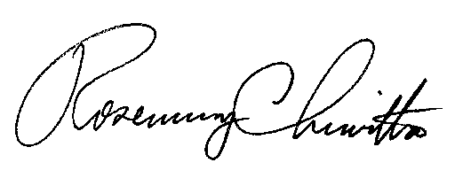
Sincerely,

Rosemary Chiavetta
Secretary

RC:AEL

