 | COMMONWEALTH OF PENNSYLVANIA  PENNSYLVANIA PUBLIC UTILITY COMMISSION  COMMONWEALTH KEYSTONE BUILDING  400 NORTH STREET  HARRISBURG, PENNSYLVANIA 17120 | IN REPLY PLEASE REFER TO OUR FILE

August 11, 2022

Service by Email

JOHN MARTORELLA, PRESIDENT
RELIABLE POWER ALTERNATIVES CORPORATION
400 GARDEN CITY PLAZA, SUITE 315
GARDEN CITY, NY 11530
Email: statelicenses@rpac.net

PAUL BELLOFF, ESQUIRE
RELIABLE POWER ALTERNATIVES CORPORATION
400 GARDEN CITY PLAZA, SUITE 315
GARDEN CITY, NY 11530

Dear Sirs:

On August 5, 2022, the Commission received the Application of Reliable Power Alternatives Corporation for approval to supply natural gas services to the public in the Commonwealth of PA. Upon initial review, the Application has been determined to be deficient for the following reasons:

- No original Proof of Publication from Harrisburg-Patriot News.
- No Bonding Letters for Columbia Gas of Pennsylvania, Inc.; Peoples Natural Gas Company LLC; Peoples Gas Company LLC; Valley Energy, Inc.; National Fuel Gas Distribution Corporation; PECO Energy Company; and UGI Utilities, Inc.

Pursuant to 52 Pa. Code §1.4, you are being advised of these deficiencies and are required to file corrections. Failure to correct the foregoing deficiencies within 20 days of the date of this letter will result in the Application being returned unfiled.
Please return your items to the above listed address and address to the attention of the Office of the Secretary.
If you have any question in regards to this letter, please contact our bureau at (717) 772-7777. Thank you
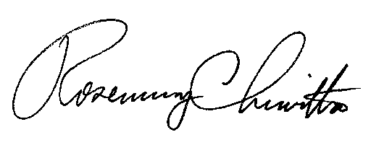
Sincerely,

Rosemary Chiavetta
Secretary

RC:AEL

