 | COMMONWEALTH OF PENNSYLVANIA  PENNSYLVANIA PUBLIC UTILITY COMMISSION  COMMONWEALTH KEYSTONE BUILDING  400 NORTH STREET  HARRISBURG, PENNSYLVANIA 17120 | IN REPLY PLEASE REFER TO OUR FILE

September 15, 2022

ALL PARTIES OF RECORD

Re: Regina Guyton vs Philadelphia Gas Works
Docket Number: F-2022-3030775

To All Parties of Record:

On September 12, 2022, my office received Exceptions to the Initial Decision of Administrative Law Judge Arlene Ashton in the above captioned matter. Our review of the filing revealed that no certificate of service or other indication that the parties of record to the case were served with the Exceptions. Therefore, we have enclosed a copy of the Exceptions to constitute service for purposes of 52 Pa. Code 5.533.

Due to the failure of Regina Guyton to provide service on all the parties of record to the case, and in order to avoid prejudice to any party pursuant to 52 Pa. Code 5.535, the Respondent shall have until October 11, 2022 to file Reply Exceptions.

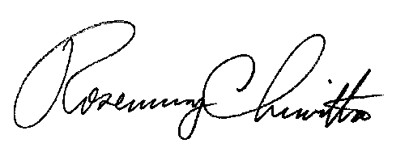
Sincerely,

Rosemary Chiavetta
Secretary

Enclosure
RC:jbs

cc: All Parties of Record
Document Folder

