 | COMMONWEALTH OF PENNSYLVANIA  PENNSYLVANIA PUBLIC UTILITY COMMISSION  COMMONWEALTH KEYSTONE BUILDING  400 NORTH STREET  HARRISBURG, PENNSYLVANIA 17120 | IN REPLY PLEASE REFER TO OUR FILE
September 27, 2022

Via Certified Mail

LISA BARRY
AMERICAN POWER & GAS OF PENNSYLVANIA LLC
10601 BELCHER ROAD SOUTH
SEMINOLE FL 33777

RE: Continuous Bond
American Power & Gas of Pennsylvania LLC
A-2013-2355561

Dear Ms. Barry:

Please find under cover of this letter the financial instrument filed with the Commission on behalf of American Power & Gas of Pennsylvania LLC because it is not acceptable.

The Commission requires a supplier to file an original bond, letter of credit, continuation certificate, amendment, or other financial instrument as part of a supplier’s licensing requirements under Section 2809(c) of the Pennsylvania Public Utility Code.

The enclosed financial instrument does not have "wet ink" original signature for the Surety company

Please file the originally signed and sealed security instrument with my office within 20 days of the date of this letter, preferably by overnight delivery.

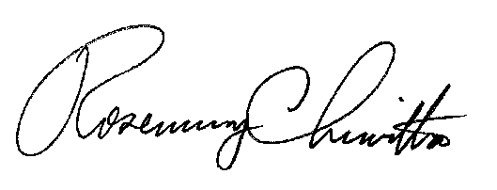
Sincerely,

Rosemary Chiavetta
Secretary of the Commission

RC:jbs

