 | COMMONWEALTH OF PENNSYLVANIA  PENNSYLVANIA PUBLIC UTILITY COMMISSION  COMMONWEALTH KEYSTONE BUILDING  400 NORTH STREET  HARRISBURG, PENNSYLVANIA 17120 | IN REPLY PLEASE REFER TO OUR FILE

November 4, 2022

Service by Email

CALEB BERGER, PRESIDENT
CAPITAL ENERGY INC
45 BROADWAY, SUITE 2230
NEW YORK, NY 10006
Email: caleb.berger@capitalenergy.net

BRADFORD STERN, ESQUIRE
ROTHFELDER STERN, L.L.C.
407 GREENWOOD AVENUE, UNIT #301
TRENTON, NJ 08609
Email: bstern@rothfelderstern.com

Dear Sirs:

On November 1, 2022, the Commission received the Application of Capital Energy Inc for approval to supply natural gas services to the public in the Commonwealth of PA. Upon initial review, the Application has been determined to be missing information for the following reason:

- The Application is outdated. Your Application must be based on the latest version of the template, accessible in the application packet on our website.

Pursuant to 52 Pa. Code §1.4, you are being advised of this missing information and are required to file corrections. Failure to correct the foregoing missing information within 20 days of the date of this letter will result in the Application being returned unfiled.
Please return your item to the above listed address and address to the attention of the Office of the Secretary.
If you have any question in regards to this letter, please contact our bureau at (717) 772-7777. Thank you
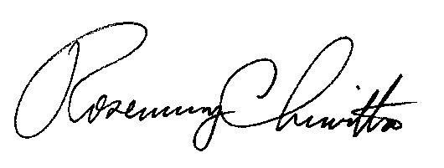
Sincerely,

Rosemary Chiavetta
Secretary

RC:AEL

