BEFORE THE
PENNSYLVANIA PUBLIC UTILITY COMMISSION

Conyngham Township :
:
v. : C-2021-3023624
:
Sanitary Sewer Authority :
of the Borough of Shickshinny :

NINTH INTERIM ORDER
CLOSING THE RECORD

AND NOW, the transcript of the October 4, 2022, hearing in this case having been docketed by the Commission’s Secretary’s Bureau in Harrisburg on October 26, 2022; and the Parties having filed their respective briefs by November 18, 2022; and no further hearings in this matter are being scheduled or held,

THEREFORE,

IT IS ORDERED:

- That the record at Docket No. C-2021-3023624 is hereby closed.

2. That the Initial Decision in this case shall be prepared and issued.

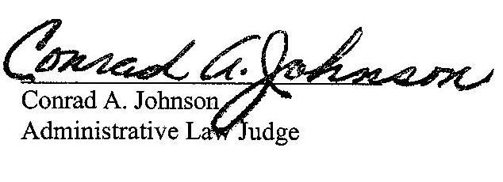
Dated: November 23, 2022

C-2021-3023624 – CONYNGHAM TOWNSHIP V. SHICKSHINNY SANITARY SEWER AUTHORITY OF THE BOROUGH OF SHICKSHINNY
VITO J DELUCA ESQUIRE
DELUCA LAW OFFICES
26 PIERCE STREET
KINGSTON PA 18704
570-288-8000
vjd@delucalawoffices.com
Accepts eService
Representing Conyngham Township

SEAN W LOGSDON ESQUIRE
85 DRASHER ROAD
DRUMS PA 18222
570-788-6647
sean@karpowichlaw.com
Accepts eService
Representing Sanitary Sewer Authority of The Borough of Shickshinny

SANITARY SEWER AUTHORITY OF THE BOROUGH OF SHICKSHINNY
1 MAIN ROAD
SHICKSHINNY PA 18655
shickauth@frontier.com

MICHAEL L SWINDLER ESQUIRE
PENNSYLVANIA PUBLIC UTILITY COMMISSION
BUREAU OF INVESTIGATION & ENFORCEMENT
400 NORTH STREET
HARRISBURG PA 17120
717-783-6369
mswindler@pa.gov
Accepts eService
Representing Bureau of Investigation & Enforcement

