 |   COMMONWEALTH OF PENNSYLVANIA  PENNSYLVANIA PUBLIC UTILITY COMMISSION  COMMONWEALTH KEYSTONE BUILDING  400 NORTH STREET  HARRISBURG, PENNSYLVANIA 17120 | IN REPLY PLEASE REFER TO OUR FILE
A-2022-3037047
December 2, 2022

Elizabeth Rose Triscari
852 Wesley Drive
Mechanicsburg, PA 17055

Dear Attorney Triscari:

The Commission acknowledges receipt of Pennsylvania-American Water Company Notice of Licensed Engineer and Utility Valuation Expert Engagement Concerning Acquisition of the Butler Area Sewer Authority Wastewater System, which was received by the Commission on December 1, 2022.

The Commission has assigned Docket No. A-2022-3037047 to the filing for document management purposes only. Future filings made with the Commission regarding Pennsylvania-American Water Company’s Acquisition of the Butler Area Sewer Authority Wastewater System should reference the above referenced “A” docket number.

This matter will receive the attention of the Commission and you will be advised of any further necessary procedure.
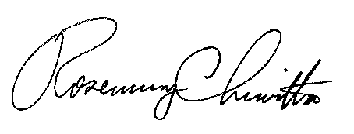
Sincerely,

Rosemary Chiavetta
Secretary

cc: Via Email only:
Patrick Cicero, Office of Consumer Advocate (via electronic mail)
NazAarah Sabree, Office of Small Business Advocate (via electronic mail)
Richard A. Kanaskie, Bureau of Investigation and Enforcement (via electronic mail)
Paul Diskin, Bureau of Technical Utility Services (via electronic mail)

