 | COMMONWEALTH OF PENNSYLVANIA  PENNSYLVANIA PUBLIC UTILITY COMMISSION  COMMONWEALTH KEYSTONE BUILDING  400 NORTH STREET  HARRISBURG, PENNSYLVANIA 17120 | IN REPLY PLEASE REFER TO OUR FILE

November 22, 2022

Service by Email

ALL PARTIES OF RECORD

Re: Christopher Haymes v. Philadelphia Gas Works
Docket Number: C-2022-3032787

To All Parties of Record:

On November 21, 2022, my office received Exceptions to the Initial Decision of Administrative Law Judge F. Joseph Brady in the above captioned matter. Our review of the filing revealed that no certificate of service or other indication that the parties of record to the case were served with the Exceptions. Therefore, we have enclosed a copy of the Exceptions to constitute service for purposes of 52 Pa. Code 5.533.

Due to the failure of Christopher Haymes to provide service on all the parties of record to the case, and in order to avoid prejudice to any party pursuant to 52 Pa. Code 5.535, the Respondent shall have until December 22, 2022 to file Reply Exceptions.

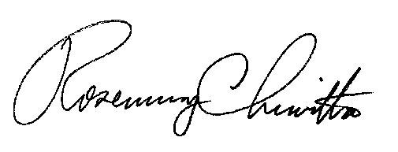
Sincerely,

Rosemary Chiavetta
Secretary

Enclosure
RC: ael

cc: All Parties of Record
Document Folder

