 | COMMONWEALTH OF PENNSYLVANIA  PENNSYLVANIA PUBLIC UTILITY COMMISSION  COMMONWEALTH KEYSTONE BUILDING  400 NORTH STREET  HARRISBURG, PENNSYLVANIA 17120 | IN REPLY PLEASE REFER TO OUR FILE

December 6, 2022

Service by Email

SOPHIA SPANGLER, ENERGY MARKETS ANALYST
BRIGHT POWER INC
11 HANOVER SQUARE, 24TH FLOOR
NEW YORK, NY 10005
Email: sspangler@brightpower.com & procurement@brightpower.com

PRISTINE JOHANNESSEN, LEGAL COUNSEL
BRIGHT POWER INC
11 HANOVER SQUARE, 21ST FLOOR
NEW YORK, NY 10005
Email: LEGAL@BRIGHTPOWER.COM

Dear Madams:

On December 2, 2022, the Commission received the Application of Bright Power Inc for approval to supply natural gas services to the public in the Commonwealth of PA. Upon initial review, the Application has been determined to be deficient for the following reason:

- Some of the information on your CD – rom copy of your application is considered as public information (per the public part of the paper filing of your Application) when you marked the entire CD – rom copy as “Confidential”. In other words, “Appendix Z (NG Business Ent), “Appendix H (Newspaper Affidavits),” “Appendix G (NG Tech Fit),” and “Appendix E (NG Bonds)” must be placed onto one CD – rom. “Appendix F (CONFIDENTIAL NG Financials)” must be placed onto another second CD – rom. Please combine all attachments on each CD – rom as one PDF document.

Pursuant to 52 Pa. Code §1.4, you are being advised of this deficiency and are required to file corrections. Failure to correct the foregoing deficiency within 20 days of the date of this letter will result in the Application being returned unfiled.
Please return your item to the above listed address and address to the attention of the Office of the Secretary.
If you have any question in regards to this letter, please contact our bureau at (717) 772-7777. Thank you.

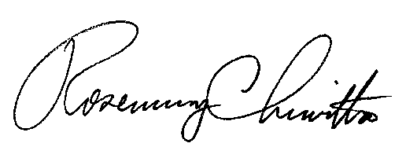
Sincerely,

Rosemary Chiavetta
Secretary

RC:AEL

