COMMONWEALTH OF PENNSYLVANIA
PENNSYLVANIA PUBLIC UTILITY COMMISSION
COMMONWEALTH KEYSTONE BUILDING
400 NORTH STREET
HARRISBURG, PENNSYLVANIA 17120

Date of Service: January 6, 2023 Docket Number: C-2023-3037504

Via e-service
EQT
Attn: Jacob Schultz
625 Liberty Avenue
Pittsburgh, PA 15222
jschultz@eqt.com

Bureau of Investigation and Enforcement
v.
EQT

Dear Mr. Schultz:

The Pennsylvania Public Utility Commission has delegated its authority to initiate prosecutory proceedings to several of its Commission bureaus with enforcement responsibilities. Pursuant to this delegated authority and Section 701 of the Public Utility Code, 66 Pa. C.S. § 701, Bureau of Investigation and Enforcement staff has filed the attached Complaint in the above docketed proceeding.

Detailed instructions on how to proceed are contained in the NOTICE section, and you are advised to read everything carefully or consult with your attorney.

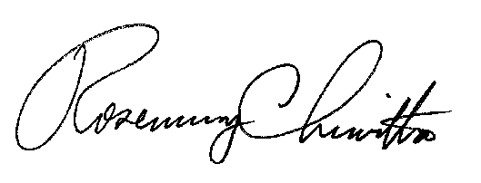
Sincerely,

Rosemary Chiavetta
Secretary

RC: jbs

ALL Parties to proceedings pending before the Commission are encouraged to EITHER open and use an efiling account through the Commission’s website at www.puc.pa.gov OR to ensure timely arrival, submit the filing by overnight delivery to: Secretary, Pennsylvania Public Utility Commission, 400 North Street, Harrisburg, Pennsylvania 17120. Emailed or faxed submissions are not acceptable. If a filing contains confidential or proprietary material, the filing should be submitted by overnight delivery to ensure arrival. Large filings containing confidential or proprietary material may also be submitted through the Commission’s Share Point File system. These filings should be followed by a hard copy with a flash drive or CD for the Commission’s file. Filers should contact the Secretary’s Bureau in advance to set up a Share Point File before submitting the filing.

