PENNSYLVANIA PUBLIC UTILITY COMMISSION

NOTICE TO BE PUBLISHED

Joint Petition of Palmerton Telephone Company, Inc., and Teleport Communications America, LLC for approval of an Interconnection and Reciprocal Compensation Agreement under Section 252 (e) of the Telecommunications Act of 1996.
Docket Number: A-2023-3037592
_____________________

Palmerton Telephone Company, Inc., and Teleport Communications America, LLC, by its counsel, filed on January 11, 2023, at the Public Utility Commission, a Joint Petition for approval of an Interconnection and Reciprocal Compensation Agreement under Sections 251 and 252 of the Telecommunications Act of 1996.

Interested parties may file comments concerning the petition and agreement. All filings must be made electronically through eFiling with the Secretary, Pennsylvania Public Utility Commission, 400 North Street, Harrisburg, PA 17120. Comments are due on or before 10 days after the date of publication of this notice. Documents filed in support of Palmerton Telephone Company, Inc., and Teleport Communications America, LLC Joint Petition are available for inspection at the Commission’s website at www.puc.pa.gov, and at the applicant’s business website.

Contact person is Kathryn Sophy, Director, Office of Special Assistants, (717) 787-1827.

BY THE COMMISSION
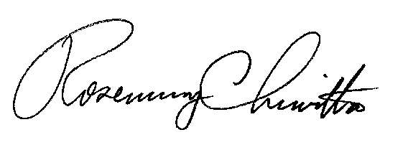

Rosemary Chiavetta
Secretary

