 | COMMONWEALTH OF PENNSYLVANIA  PENNSYLVANIA PUBLIC UTILITY COMMISSION  COMMONWEALTH KEYSTONE BUILDING  400 NORTH STREET  HARRISBURG, PENNSYLVANIA 17120 | IN REPLY PLEASE REFER TO OUR FILE

January 27, 2023

A-2014-2445962

Served by EService

TODD STEWART, ESQUIRE
HAWKE MCKEON & SNISCAK LLP
101 NORTH TENTH STREET
HARRISBURG, PA 17101
Email: tsstewart@hmslegal.com

Dear Mr. Stewart:

On January 25, 2023, the Commission received your filing deemed Name Change Request from Convenient Ventures LLC d/b/a EnergyObjective to Convenient Ventures LLC d/b/a EnergyObjective d/b/a Shipley Energy Advisors. It has been determined your filing is deficient for the following reason:

The required $350.00 filing fee is missing.

Please be advised that you are directed to forward the requested information to the Commission within 20 days from the date of this letter. Failure to respond may cause Commission staff to initiate a formal proceeding that may lead to cancellation of Convenient Ventures LLC d/b/a EnergyObjective’s, natural gas supplier license, fines and penalties, removal of the company’s information from the Commission’s website, and notification to all gas distribution companies in which Convenient Ventures LLC d/b/a EnergyObjective is licensed to do business.

Should you have any questions please contact our Bureau at 717-772-7777.

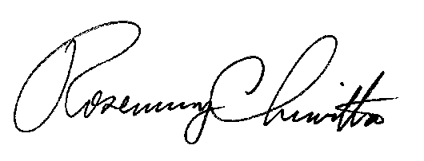
Sincerely,

Rosemary Chiavetta
Secretary

RC: AEL

cc: File Room
Technical Utility Services

