 | COMMONWEALTH OF PENNSYLVANIA  PENNSYLVANIA PUBLIC UTILITY COMMISSION  COMMONWEALTH KEYSTONE BUILDING  400 NORTH STREET  HARRISBURG, PENNSYLVANIA 17120 | IN REPLY PLEASE REFER TO OUR FILE

January 9, 2023

Service by Email

SHANNON BEDRICH, VICE PRESIDENT
PENNSYLVANIA CYPRESS CAPITAL VENTURES LLC
D/B/A NATURALGASPLANS.COM
13603 LAKEHILLS VIEW CIRCLE
CYPRESS, TX 77429
Email: shannon.bedrich@cypresscapitalventures.com

NATARA FELLER, ESQUIRE
FELLER LAW GROUP, PLLC
159 20TH STREET, #1B
BROOKLYN, NY 11232
Email: regulatory@feller.law

Dear Madams:

On December 29, 2022, the Commission received the Application of Pennsylvania Cypress Capital Ventures LLC d/b/a NaturalGasPlans.com for approval to supply natural gas services to the public in the Commonwealth of PA. Upon initial review, the Application has been determined to be deficient for the following reason:

- The Application is outdated. Your Application must be based on the latest version of the template, accessible in the application packet on our website.

Pursuant to 52 Pa. Code §1.4, you are being advised of this deficiency and are required to file corrections. Failure to correct the foregoing missing information within 20 days of the date of this letter will result in the Application being returned unfiled.
Please return your item to the above listed address and address to the attention of the Office of the Secretary.
If you have any question in regards to this letter, please contact our bureau at (717) 772-7777. Thank you
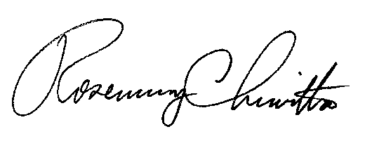
Sincerely,

Rosemary Chiavetta
Secretary

RC:AEL

