BEFORE THE
PENNSYLVANIA PUBLIC UTILITY COMMISSION

Leonardo Sanchez :
:
v. : F-2022-3037286
:
PECO Energy Company :

FIRST INTERIM ORDER
GRANTING RESPONDENT’S MOTION FOR HEARING CONTINUANCE

By Notice dated January 24, 2023, the Parties were informed that an Initial Call-In Telephonic Hearing was scheduled before me for the captioned proceeding on Wednesday, March 8, 2023, at 10:00 a.m. On February 23, 2023, Respondent PECO Energy Company filed a Motion for Continuance of Hearing Date. As grounds for the hearing continuance, Respondent represented that the parties had agreed to conduct an in-person high bill field visit at the Complainant Leonardo Sanchez’s home, due to his billing dispute. The inspection was scheduled to take place on March 3, 2023.

After due consideration, I find that the motion states good cause to warrant a continuance. Thus, the motion will be granted in the ordering paragraphs below. A notice rescheduling the initial hearing will be issued to the Parties.

The parties are encouraged to talk with each other to resolve this matter or a
portion thereof. It is the Commission’s policy to encourage settlements. 52 Pa. Code §5.231.

THEREFORE,

IT IS ORDERED:

- That the motion of Respondent PECO Energy Company for a continuance
of the Initial Call-In Telephonic Hearing scheduled in this proceeding for Wednesday, March 8, 2023, is granted.

- That the Scheduling Staff of the Office of Administrative Law Judge shall reschedule the Initial Call-In Telephonic Hearing in the case of Leonardo Sanchez v. PECO Energy Company at Docket No. F-2022-3037286, and so notify the parties in writing.
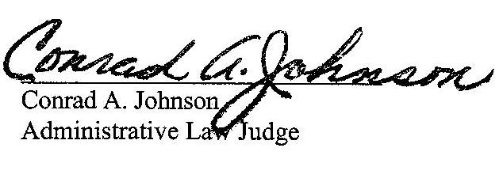

Date: March 6, 2023

F-2022-3037286 - LEONARDO SANCHEZ v. PECO ENERGY COMPANY-ELECTRIC
LEONARDO SANCHEZ
109 CRUMP ROAD
EXTON PA 19341
267.972.7176
LEOANDVERO@GMAIL.COM
KHADIJAH SCOTT ASSOCIATE GENERAL COUNSEL
PECO ENERGY COMPANY
2301 MARKET ST
S23-1
PHILADELPHIA PA 19103
215.841.6841
KHADIJAH.SCOTT@EXELONCORP.COM
Accepts EService

