 | COMMONWEALTH OF PENNSYLVANIA  PENNSYLVANIA PUBLIC UTILITY COMMISSION  COMMONWEALTH KEYSTONE BUILDING  400 NORTH STREET  HARRISBURG, PENNSYLVANIA 17120 | IN REPLY PLEASE REFER TO OUR FILE

March 3, 2023

Via E-mail: caliscarrier@gmail.com
CAMERON GOLDING
CALI’S CARRIER LLC
PO BOX 2
HYDE PA 16843

Dear Sir/Madam:

On February 24, 2023, the Commission received your Application for Motor Common Carrier or Motor Contract Carrier of Household Goods in Use of Cali’s Carrier, LLC. Upon initial review, the Application is missing the following items needed in order to accept it as a filing.

- $350.00 filing fee must be in the form of a certified check or money order (as stated in the application instructions). Personal or checks drawn from a corporate account are not accepted.

Pursuant to 52 Pa. Code §1.4, you are required to correct these items. Failure to do so within 20 days of the date of this letter will result in the Application being returned unfiled.
Please return your items to the above listed address and address to the attention of Amanda Clouser, Legal Assistant II no later than March 22, 2023.

Should you have any questions pertaining to your application, please contact our Bureau at 717-772-7777.

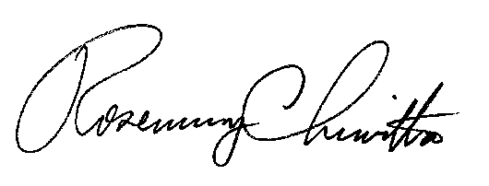
Sincerely,

Rosemary Chiavetta
Secretary

RC:anc

Enclosure: $350.00 Personal Check # 07292203

