BEFORE THE
PENNSYLVANIA PUBLIC UTILITY COMMISSION

Conyngham Township :
:
v. : C-2021-3023624
:
Sanitary Sewer Authority :
of the Borough of Shickshinny :

ELEVENTH INTERIM ORDER
RECLOSING THE RECORD

The evidentiary hearing convened in this proceeding on October 4, 2022. The Parties to this proceeding, Conyngham Township, the Sanitary Sewer Authority of the Borough of Shickshinny, and the Commission’s Bureau of Investigation and Enforcement, offered testimony and exhibits during the hearing. The Parties’ written testimonies and exhibits (collectively exhibits) were admitted into the record, and the Parties submitted their respective admitted exhibits to the court reporter for inclusion with the transcript for the evidentiary hearing.

On October 26, 2022, the transcript of the evidentiary hearing was filed with the Commission’s Secretary’s Bureau (Secretary) in Harrisburg. On November 23, 2022, a Ninth Interim Order Closing the Record was issued. On February 1, 2023, a Tenth Interim Order Opening The Record For The Docketing Of The Parties’ Admitted Written Testimonies And Exhibits (Tenth Interim Order) was issued. The Tenth Interim Order was issued for the court reporter to submit the admitted exhibits to the Secretary for docketing.

On February 23, 2023, the transcript for the evidentiary hearing and the admitted exhibits were submitted by the court reporter to the Secretary, and the admitted exhibits were docketed by the Secretary.

On March 8, 2023, the undersigned presiding officer received in Pittsburgh a copy of the transcript submitted by the court reporter to the Secretary on February 23, 2023. No further hearings in this matter will be scheduled for this proceeding.

THEREFORE,

IT IS ORDERED:

- That the record at Docket No. C-2021-3023624 is hereby reclosed.

2. That the Initial Decision in this case shall be prepared and issued.
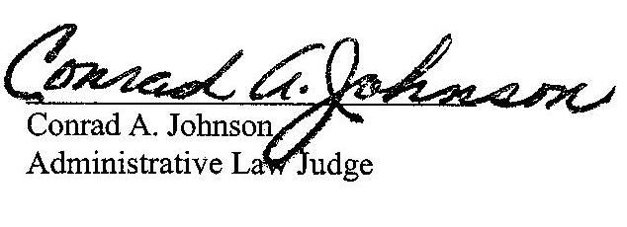

Dated: March 14, 2023

C-2021-3023624 – CONYNGHAM TOWNSHIP V. SHICKSHINNY SANITARY SEWER AUTHORITY OF THE BOROUGH OF SHICKSHINNY
VITO J DELUCA ESQUIRE
DELUCA LAW OFFICES
26 PIERCE STREET
KINGSTON PA 18704
570-288-8000
vjd@delucalawoffices.com
Accepts eService
Representing Conyngham Township

SEAN W LOGSDON ESQUIRE
85 DRASHER ROAD
DRUMS PA 18222
570-788-6647
sean@karpowichlaw.com
Accepts eService
Representing Sanitary Sewer Authority of The Borough of Shickshinny

SANITARY SEWER AUTHORITY OF THE BOROUGH OF SHICKSHINNY
1 MAIN ROAD
SHICKSHINNY PA 18655
shickauth@frontier.com

MICHAEL L SWINDLER ESQUIRE
PENNSYLVANIA PUBLIC UTILITY COMMISSION
BUREAU OF INVESTIGATION & ENFORCEMENT
400 NORTH STREET
HARRISBURG PA 17120
717-783-6369
mswindler@pa.gov
Accepts eService
Representing Bureau of Investigation & Enforcement

