 | COMMONWEALTH OF PENNSYLVANIA  PENNSYLVANIA PUBLIC UTILITY COMMISSION  COMMONWEALTH KEYSTONE BUILDING  400 NORTH STREET  HARRISBURG, PENNSYLVANIA 17120 | IN REPLY PLEASE REFER TO OUR FILE

March 22, 2023
F-2023-3037611

Via E-mail: bbeard@eckertseamans.com
BRYCE BEARD
ECKERT SEAMANS CHERIN & MELLOTT LLC
213 MARKET ST 8TH FL
HARRISBURG PA 17101

ROB NABORN
v.
DIRECT ENERGY SERVICES, LLC.

Dear Mr. Beard:

Attached is a copy of an amended complaint filed on behalf of the co-complainant in the above titled proceeding.

Such answer as you desire to make to the amended complaint should be filed in this Office and served upon the complainant within twenty days from receipt of this letter.

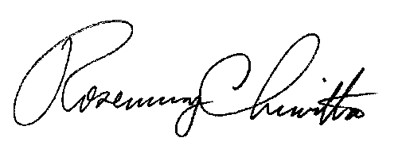
Very truly yours,

Rosemary Chiavetta
Secretary

RC:anc

