BEFORE THE
PENNSYLVANIA PUBLIC UTILITY COMMISSION

Erek Perkowski :
:
v. : C-2022-3036337
:
UGI Utilities, Inc. :

FIRST INTERIM ORDER
GRANTING COMPLAINANT’S MOTION FOR HEARING CONTINUANCE

By Notice dated March 8, 2023, the Parties were informed that a Further Call-In Telephone Hearing was scheduled before me for the captioned proceeding on Tuesday, April 11, 2023, at 10:00 a.m. By email dated March 29, 2023, Complainant Erek Perkowski requested a continuance of the hearing. As ground for the continuance, Complainant represented that he had a scheduling conflict with another legal proceeding. Complainant further represented that counsel for Respondent UGI Utilities, Inc., did not object to the continuance request.

Although Complainant’s email requesting a hearing continuance does not conform to the requirements of a formal motion under Section 1.15(b) of the Commission’s regulations, waiver of this requirement is permitted. Under Section 1.2, 52 Pa. Code § 1.2, a presiding officer at any stage of an action or proceeding may waive a requirement of a rule when necessary or appropriate if waiver does not adversely affect a substantive right of a party. Such are the circumstances in this case. Therefore, Complainant’s email dated March 29, 2023, is treated as a motion for continuance of the scheduled hearing.

After due consideration, I find that the motion states good cause to warrant a continuance. Thus, the motion will be granted in the ordering paragraphs below. A notice rescheduling the initial hearing will be issued to the Parties.

The parties are encouraged to talk with each other to resolve this matter or a
portion thereof. It is the Commission’s policy to encourage settlements. 52 Pa. Code §5.231.

THEREFORE,

IT IS ORDERED:

- That the motion of Complainant Erek Perkowski for a continuance of the Further Call-In Telephone Hearing scheduled in this proceeding for Tuesday, April 11, 2023, is granted.

- That the Scheduling Staff of the Office of Administrative Law Judge shall reschedule the Further Call-In Telephone Hearing in the case of Erek Perkowski v. UGI Utilities, Inc., at Docket No. C-2022-3036337, and so notify the parties in writing.
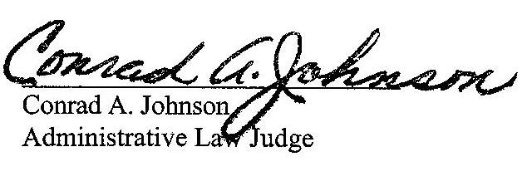

Date: March 30, 2023

C-2022-3036337 - EREK PERKOWSKI v. UGI UTILITIES, INC (GAS DIVISION)
EREK PERKOWSKI
612 MARCH ST
SHILLINGTON PA 19607
717.990.1482
MISTERPERKOWSKI@GMAIL.COM
Accepts EService
LARRY R CRAYNE ESQUIRE
238 JOHNSTON ROAD
PITTSBURGH PA 15241
412.831.5462
LRCRAYNE@COMCAST.NET
Accepts EService

