BEFORE THE
PENNSYLVANIA PUBLIC UTILITY COMMISSION

Frank J. Cservak, Jr. :
:
v. : C-2022-3036252 :
Duquesne Light Company :

INTERIM ORDER
CLOSING THE RECORD

AND NOW, the transcript of the February 15, 2023, hearing in this case having been received by the Commission’s Secretary’s Bureau in Harrisburg on March 14, 2023; and a copy of the transcript having been received by me in the Commission’s Office of Administrative Law Judge in Pittsburgh on March 23, 2023; and no further hearings in this matter are to be scheduled or held,

THEREFORE,

IT IS ORDERED:

- That the record at Docket No. C-2022-3036252 is hereby closed.

2. That the Initial Decision in this case shall be prepared and issued.

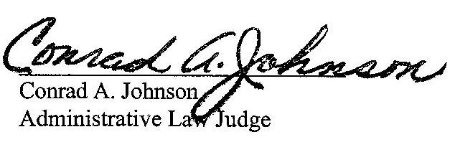
Dated: April 6, 2023

C-2022-3036252 - FRANK J CSERVAK JR v. DUQUESNE LIGHT COMPANY
FRANK J CSERVAK JR
174 BARBERRY ROAD
SEWICKLEY PA 15143
412.427.4385
fcservak@c-mservices.com
Accepts eService
MICHAEL A GRUIN ESQUIRE
STEVENS & LEE
17 NORTH SECOND STREET
16TH FLOOR
HARRISBURG PA 17101
717.255.7365
michael.gruin@stevenslee.com
Accepts eService
(Counsel for Duquesne Light Company)
DONALD R WAGNER ESQUIRE
DAVID BEANE ESQUIRE
STEVENS & LEE
111 N 6TH STREET
READING PA 19601
610.478.2216
610.478.2169
donald.wagner@stevenslee.com
david.beane@stevenslee.com
Accepts eService
(Counsel for Duquesne Light Company)

