BEFORE THE
PENNSYLVANIA PUBLIC UTILITY COMMISSION

Charlene Miller :
: C-2022-3032554
v. :
:
Peoples Natural Gas Company :

THIRD INTERIM ORDER CLOSING THE RECORD

On March 13, 2023, in this proceeding, I issued a Second Interim Order Admitting Respondent’s Late File Exhibit Into The Record Subject To Timely Objection (Second Interim Order). Under the Second Interim Order, Respondent Peoples Natural Gas Company’s Late-Filed Exhibit I (Exhibit I) was admitted into the record, subject to Complainant Charlene Miller filing objections to the admission of Exhibit I into the record by March 27, 2023. As of the date of the below order, Complainant has not filed any objection to the admission of Exhibit I. Accordingly, Exhibit I is admitted into the record, and the record will be closed in the ordering paragraphs below.

THEREFORE,

IT IS ORDERED:

- That the record at Docket No. C-2022-3032554 is hereby closed.

2. That the Initial Decision in this case shall be prepared and issued.

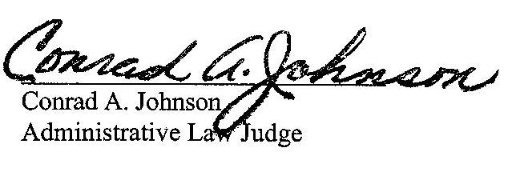
Dated: April 7, 2023

C-2022-3032554 - CHARLENE MILLER v. PEOPLES NATURAL GAS COMPANY
CHARLENE MILLER
301 BESSEMER AVE APT 8
EAST PITTSBURGH PA 15112
412.377.0271
charlenemiller8261958@gmail.com
JENNIFER L. PETRISEK ESQUIRE
375 NORTH SHORE DRIVE
PITTSBURGH PA 15212
412.208.6834
Jennifer.Petrisek@peoples-gas.com
Accepts eService
(Counsel for Peoples Natural Gas Company LLC)

