 | COMMONWEALTH OF PENNSYLVANIA  PENNSYLVANIA PUBLIC UTILITY COMMISSION  COMMONWEALTH KEYSTONE BUILDING  400 NORTH STREET  HARRISBURG, PENNSYLVANIA 17120 | IN REPLY PLEASE REFER TO OUR FILE

April 26, 2023

Service by Email

NATASHA WATSON, EXECUTIVE OFFICER
GENTLE OPTIONS NEMT LLC
134 COUNTRY CLUB DRIVE
LANSDALE, PA 19446
Email: natasha@usraah.org & usraahifs@gmail.com

Dear Madam:

On April 25, 2023, the Commission received your Application for Motor Common Carrier of Persons in Paratransit Service from Gentle Options NEMT LLC. Upon initial review, the Application is missing the following item needed in order to accept it as a filing.

- Your required $350.00 filing fee is missing.

Pursuant to 52 Pa. Code §1.4, you are required to correct this item. Failure to do so within 20 days of the date of this letter will result in the Application being returned unfiled.

Should you have any questions pertaining to your Application, please contact our Bureau at 717-772-7777.

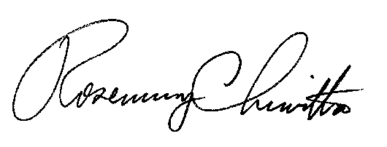
Sincerely,

Rosemary Chiavetta
Secretary

Enclosure

RC:AEL

