PENNSYLVANIA PUBLIC UTILITY COMMISSION
NOTICE TO BE PUBLISHED

Petition of Pike County Light & Power Company for Approval of a
Default Service Plan and Waiver of Commission Regulations for the Period June 1, 2024 through May 31, 2027.
Docket Number: P-2023-3039927
___________________________________________________

Formal Protests, Petitions to Intervene and Answers must be filed in
Accordance with Title 52 of the Pennsylvania Code on or before
June 9, 2023. All filings must be made with the Secretary of the
Pennsylvania Public Utility Commission, 400 North Street, Harrisburg,
PA 17120, with a copy served on the Petitioner and a copy
provided to the Administrative Law Judge. The documents filed in
support of the Petition are available for inspection and copying at the Office of the Secretary between the hours of 8:00 a.m. and 4:30 p.m., Monday through Friday, and at the Petitioner’s business address.

Applicant:
Pike County Light & Power Company
Through and by Counsel:
Whitney E. Snyder, Esquire
Hawke McKeon & Sniscak LLP
100 North Tenth Street
Harrisburg, PA 17101
wesnyder@hmslegal.com

Initial Telephonic Prehearing Conference Notice

This is to inform you that an initial telephonic prehearing conference on the above-captioned case will be held as follows:

Type: Initial Call-In Telephonic Prehearing Conference

Date: Thursday, June 15, 2023

Time: 10:00 A.M.

Presiding: Deputy Chief Administrative Law Judge Mark A. Hoyer
Phone: 412.565.3550 Fax: 717.231.4765

To participate in the Telephonic Prehearing Conference,

- You must dial the toll-free Conference number below
- You must enter the PIN number below when instructed
- You must speak your name when prompted, and press #
- Then the telephone system will connect you to the conference

Toll-free Conference Number: 866.566.0651
PIN Number: 59956427

Individuals representing themselves are not required to be represented by an attorney. All others (corporation, partnership, association, trust or governmental agency or subdivision) must be represented by an attorney. An attorney representing you should file a Notice of Appearance before the scheduled hearing date.

If you require an interpreter to participate in the conference, we will make every reasonable effort to have an interpreter present. Please call the scheduling office at the Public Utility Commission at least ten (10) business days prior to your hearing to submit your request.

- Scheduling Office: 717.787.1399
- AT&T Relay Service number for persons who are deaf or hearing-impaired: 1.800.654.5988

The Public Utility Commission offers a free e-Filing Subscription Service, which allows users to automatically receive an email notification whenever a document is added, removed, or changed on the PUC website regarding a specific case. Instructions for subscribing to this service are on the PUC’s website at http://www.puc.pa.gov/Documentation/eFiling_Subscriptions.pdf.

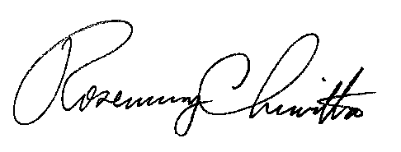
BY THE COMMISSION

Rosemary Chiavetta
Secretary

