 | COMMONWEALTH OF PENNSYLVANIA  PENNSYLVANIA PUBLIC UTILITY COMMISSION  COMMONWEALTH KEYSTONE BUILDING  400 NORTH STREET  HARRISBURG, PENNSYLVANIA 17120 | IN REPLY PLEASE REFER TO OUR FILE

Date: May 5, 2023

Certified Mail
STEVE KACHER
110 WAYNE ST
CARBONDALE PA 18407

Dear Mr. Kacher:

We are in receipt of a personal check in the amount of $1,150.00 (#4347) that was filed towards a fine payment for C-2022-3032350. The Commission does not accept personal checks or checks drawn from a Corporate account so the filing fee cannot be accepted and is being returned to you. Please forward a certified check or money order to the Commission to satisfy the fine payment. We apologize for the inconvenience.

Sincerely,

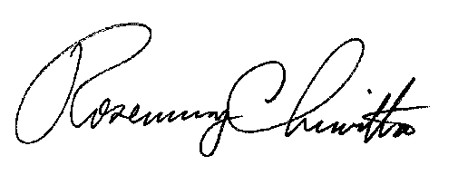
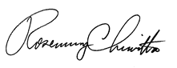

Rosemary Chiavetta
Secretary of the Commission

Enclosure: Personal Check - $1,150.00 - #4347

RC:anc

