 | COMMONWEALTH OF PENNSYLVANIA  PENNSYLVANIA PUBLIC UTILITY COMMISSION  COMMONWEALTH KEYSTONE BUILDING  400 NORTH STREET  HARRISBURG, PENNSYLVANIA 17120 | IN REPLY PLEASE REFER TO OUR FILE

May 9, 2023

IN REPLY PLEASE
REFER TO OUR FILE

A-2023-3040560

Service by EService

SUZAN D. PAIVA, ASSISTANT GENERAL COUNSEL
VERIZON PENNSYLVANIA LLC
900 RACE STREET, 6TH FLOOR
PHILADELPHIA, PA 19107
Email: suzan.d.paiva@verizon.com

Application of Verizon Pennsylvania LLC for Approval to Lower an Aerial Cable Located in the Borough of Old Forge, Lackawanna County. To Complete This Work Verizon Pennsylvania LLC Must Work over the Reading Blue Mountain & Northern Railroad Company in the Public Right of Way of Moosic Street Crossing #266-115F.

Dear Madam:

Receipt is acknowledged of the application of Verizon Pennsylvania LLC which has been captioned and docketed to the above number.

We note that you have served copies of the application upon the parties involved.

The matter will receive the Commission's attention, and you will be advised of any further procedure.

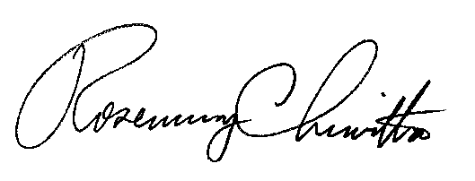
Very truly yours,

Rosemary Chiavetta
Secretary

RC:AEL

