 | COMMONWEALTH OF PENNSYLVANIA  PENNSYLVANIA PUBLIC UTILITY COMMISSION  COMMONWEALTH KEYSTONE BUILDING  400 NORTH STREET  HARRISBURG, PENNSYLVANIA 17120 | IN REPLY PLEASE REFER TO OUR FILE

April 27, 2023

Via E-mail: homrighausenmark2@gmail.com
MARK HOMRIGHAUSEN
AUSSIE BEAGLE TRUCKING LLC
42 NOTCH RD
DUNCANNON PA 17020

Dear Mr. Homrighausen:

On April 19, 2023, the Commission received your Application for Motor Common Carrier of Aussie Beagle Trucking, LLC. Upon initial review, the Application is missing the following items needed in order to accept it as a filing.

- $100.00 Filing Fee must be in the form of a certified check or money order (as stated in the application instructions). Personal and checks drawn from a Corporate account are not accepted.
- Line one of application should match the name registered with the Pennsylvania Department of State Corporation Bureau (Aussie Beagle Trucking, LLC.).
- Line two of application should be left blank.
Pursuant to 52 Pa. Code §1.4, you are required to correct these items. Failure to do so within 20 days of the date of this letter will result in the Application being returned unfiled.
Please return your items to the above listed address and address to the attention of Amanda Clouser, Legal Assistant II no later than May 17, 2023.

Should you have any questions pertaining to your application, please contact our Bureau at 717-772-7777.

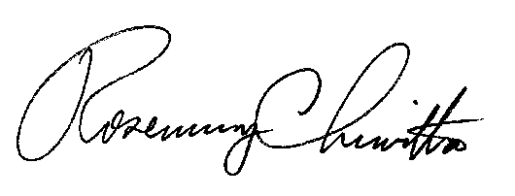
Sincerely,

Rosemary Chiavetta
Secretary

RC:anc

Enclosure: $100.00 Personal Check # 0994

