 | COMMONWEALTH OF PENNSYLVANIA  PENNSYLVANIA PUBLIC UTILITY COMMISSION  COMMONWEALTH KEYSTONE BUILDING  400 NORTH STREET  HARRISBURG, PENNSYLVANIA 17120 | IN REPLY PLEASE REFER TO OUR FILE

May 16, 2023

Service by Postal Service

Mr. Robert Lienhard
719 Lehigh Street
Jim Thorpe, PA 18229

Dear Mr. Lienhard:

I am in receipt of your Formal Complaint to Proposed Rate Increase of May 12, 2023. You name PPL Electric Utilities Corporation as a Respondent in your Formal Complaint to Proposed Rate Increase. However, PPL Electric Utilities Corporation has no rate case filed with the Commission at this time. If there is some other matter or issue regarding PPL Electric Utilities Corporation, in which you wish to file a Formal Complaint, please fill out a separate Complaint form, sign it and send it to my office.

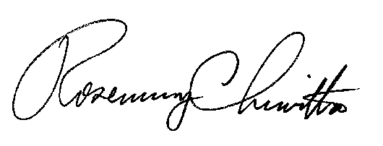
Sincerely,

Rosemary Chiavetta, Secretary

Enclosure

RC:AEL

