BEFORE THE
PENNSYLVANIA PUBLIC UTILITY COMMISSION

Leonardo Sanchez :
:
v. : F-2022-3037286 :
PECO Energy Company :

INTERIM ORDER
CLOSING THE RECORD

AND NOW, the transcript of the April 25, 2023, hearing in this case having been received by the Commission’s Secretary’s Bureau in Harrisburg on May 17, 2023; and a copy of the transcript having been received by me in the Commission’s Office of Administrative Law Judge in Pittsburgh on June 8, 2023; and no further hearings in this matter are to be scheduled or held,

THEREFORE,

IT IS ORDERED:

- That the record at Docket No. F-2022-3037286 is hereby closed.

2. That the Initial Decision in this case shall be prepared and issued.

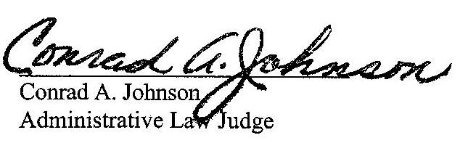
Dated: June 14, 2023

F-2022-3037286 - LEONARDO SANCHEZ v. PECO ENERGY COMPANY-ELECTRIC
LEONARDO SANCHEZ
109 CRUMP ROAD
EXTON PA 19341
267.972.7176
LEOANDVERO@GMAIL.COM
KHADIJAH SCOTT ASSOCIATE GENERAL COUNSEL
PECO ENERGY COMPANY
2301 MARKET ST
S23-1
PHILADELPHIA PA 19103
215.841.6841
KHADIJAH.SCOTT@EXELONCORP.COM
Accepts EService
PREDRAG FILIPOVIC, ESQ.
1635 MARKET STREET, STE.1610
PHILADELPHIA, PA 19103
267.265.0520
PFESQ@IFIGHT4JUSTICE.COM
Accepts eService

