PENNSYLVANIA PUBLIC UTILITY COMMISSION

NOTICE TO BE PUBLISHED

Joint Petition of Commonwealth Telephone Company d/b/a Frontier Communications Commonwealth Telephone Company and Comcast Business Communications, LLC for approval of an Amendment to the Interconnection Agreement under Section 252 (e) of the Telecommunications Act of 1996.
Docket Number: A-2023-3041419
_____________________

Commonwealth Telephone Company d/b/a Frontier Communications Commonwealth Telephone Company and Comcast Business Communications, LLC by its counsel, filed on June 22, 2023, at the Public Utility Commission, a Joint Petition for approval of an Amendment to the Interconnection Agreement under Sections 251 and 252 of the Telecommunications Act of 1996.

Interested parties may file comments concerning the petition and agreement. All filings must be made electronically through eFiling with the Secretary, Pennsylvania Public Utility Commission, 400 North Street, Harrisburg, PA 17120. Comments are due on or before 10 days after the date of publication of this notice. Documents filed in support of Commonwealth Telephone Company d/b/a Frontier Communications Commonwealth Telephone Company and Comcast Business Communications, LLC Joint Petition are available for inspection at the Commission’s website at www.puc.pa.gov, and at the applicant’s business website.

Contact person is Kathryn Sophy, Director, Office of Special Assistants, (717) 787-1827.

BY THE COMMISSION
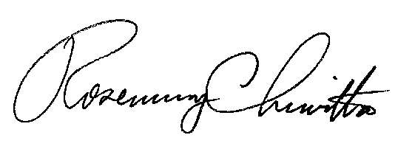

Rosemary Chiavetta
Secretary

