 | COMMONWEALTH OF PENNSYLVANIA  PENNSYLVANIA PUBLIC UTILITY COMMISSION  COMMONWEALTH KEYSTONE BUILDING  400 NORTH STREET  HARRISBURG, PENNSYLVANIA 17120 | IN REPLY PLEASE REFER TO OUR FILE

May 24, 2023

Served by Email and Postal Service

FRANK SNIEZEK, DIVISION HR ADMINISTRATOR
RENODIS ER, LLC
D/B/A ERIC RYAN COMPANY
1 EARLY STREET, SUITE A
ELLWOOD CITY, PA 16117
Email: fsniezek@ericryan.com

Dear Sir:

On May 11, 2023, the Commission received the Application of Renodis ER, LLC d/b/a Eric Ryan Company for approval to supply natural gas services to the public in the Commonwealth of PA. Upon initial review, the Application has been determined to be deficient for the following reasons:

- The Legal and Fictious Names “Renodis ER, LLC d/b/a Eric Ryan Company” have been listed incorrectly throughout the entire application. “Renodis ER, LLC d/b/a Eric Ryan Company” must be inserted throughout the entire application exactly as it appears on your Pennsylvania Department of State Corporation Bureau website.

- No filing fee of $350.00.

- No Original Signatures.

Pursuant to 52 Pa. Code §1.4, you are being advised of this missing information and are required to file corrections. Failure to correct the foregoing missing information within 20 days of the date of this letter will result in the Application being returned unfiled.
Please return your items to the above listed address and address to the attention of the Office of the Secretary.

If you have any question in regards to this letter, please contact our bureau at (717) 772-7777. Thank you
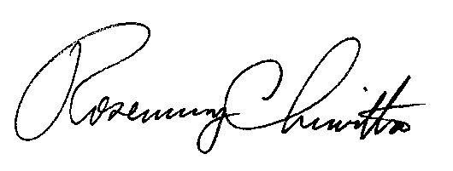
Sincerely,

Rosemary Chiavetta
Secretary

Enclosure

RC:AEL

