BEFORE THE
PENNSYLVANIA PUBLIC UTILITY COMMISSION

Robert Adams :
:
v. : C-2022-3032837 :
Zito Media Voice, LLC :

ORDER

This Order is issued pursuant to the authority of Commission Administrative Law Judges set forth in the Pennsylvania Public Utility Code at 66 Pa. C.S. § 331 and the regulations of the Commission at 52 Pa. Code § 5.483.

On May 20, 2022, Robert Adams (Complainant) filed a formal Complaint against Zito Media Voice, LLC (Zito or Respondent), alleging inadequate telephone and internet service and requesting a refund from Zito for services not received.

On February 14, 2023, a telephonic hearing convened pursuant to Notice. Complainant was present and represented himself. Maria T. Browne, Esquire, appeared on behalf of Respondent. No exhibits were offered by either party.

On March 14, 2023, an 18-page transcript was filed by the court reporting service.

Absent from the record is a copy of the Certificate of Public Convenience issued by the Commission on January 12, 2023, which certified the abandonment of service by Respondent. In order to provide a complete record for review, that document, a copy of which is attached, is admitted to the record as ALJ Attachment 1.

THEREFORE.

IT IS ORDERED:

1. That a copy of the Certificate of Public Convenience issued by the Commission on January 12, 2023, which certified the abandonment of service by Respondent is admitted to the record as ALJ Attachment 1.

2. The record in this matter is closed, and an Initial Decision will be forthcoming.

Date: July 12, 2022 /s/
Dennis J. Buckley
Administrative Law Judge

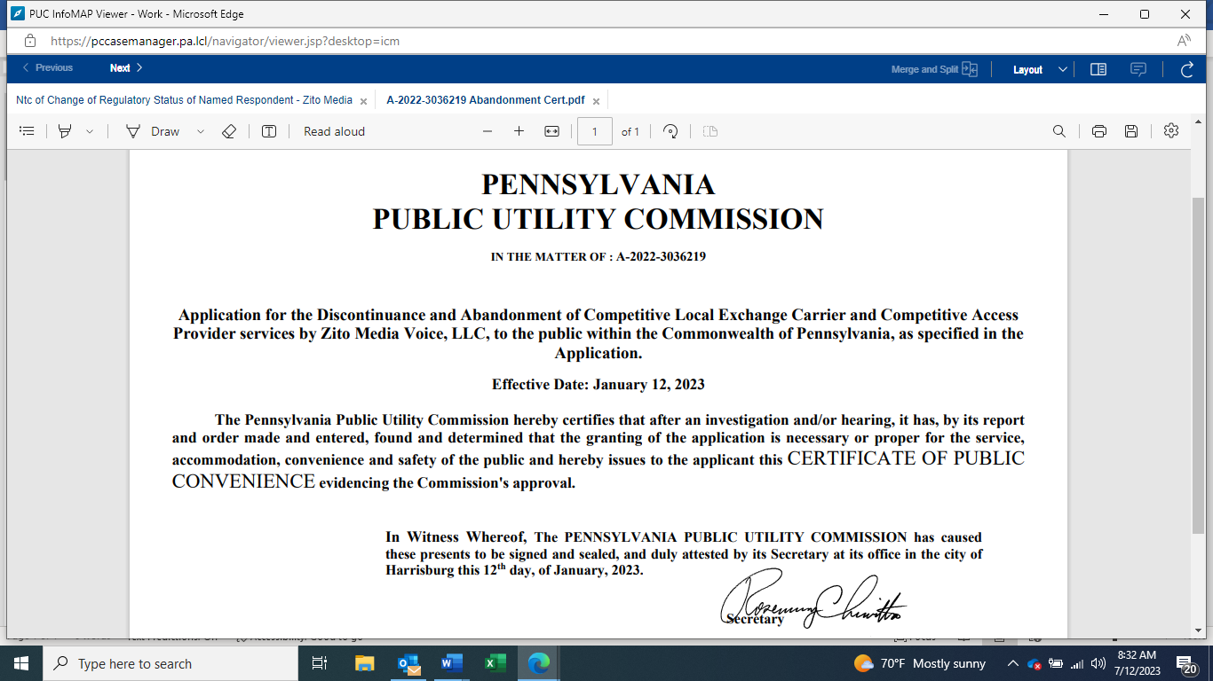

ALJ ATTACHMENT 1

C-2022-3032837 - ROBERT ADAMS v. ZITO MEDIA VOICE, LLC
ROBERT ADAMS
514 JULIAN PIKE
JULIAN PA 16844
814.355.2998
RADAMS223@YAHOO.COM
COLIN HIGGIN VP AND GENERAL COUNSEL
ZITO MIFFLIN COUNTY LLC
102 SOUTH MAIN STREET
COUDERSPORT PA 16915
814.260.9588
COLIN.HIGGIN@ZITOMEDIA.COM
Accepts EService

