 | COMMONWEALTH OF PENNSYLVANIA  PENNSYLVANIA PUBLIC UTILITY COMMISSION  COMMONWEALTH KEYSTONE BUILDING  400 NORTH STREET  HARRISBURG, PENNSYLVANIA 17120 | IN REPLY PLEASE REFER TO OUR FILE

July 26, 2023

Service by EService

ALL PARTIES OF RECORD

Re: Frank J. Cservak, Jr., P.E. v. Duquesne Light Company
Docket Number: C-2022-3036252

To All Parties of Record:

On July 24, 2023, my office received Exceptions to the Initial Decision of Administrative Law Judge Conrad A. Johnson in the above captioned matter. Our review of the filing revealed that no certificate of service or other indication that the parties of record to the case were served with the Exceptions. Therefore, we have enclosed a copy of the Exceptions to constitute service for purposes of 52 Pa. Code 5.533.

Due to the failure of Frank J. Cservak, Jr., P.E., to provide service on all the parties of record to the case, and in order to avoid prejudice to any party pursuant to 52 Pa. Code 5.535, the Respondent shall have until August 11, 2023, to file Reply Exceptions.

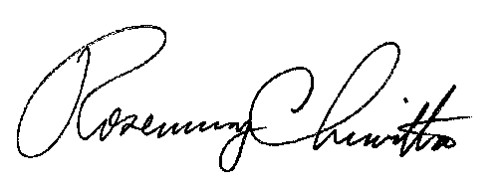
Sincerely,

Rosemary Chiavetta
Secretary

Enclosure
RC: ael

cc: All Parties of Record
Document Folder

