 | COMMONWEALTH OF PENNSYLVANIA  PENNSYLVANIA PUBLIC UTILITY COMMISSION  COMMONWEALTH KEYSTONE BUILDING  400 NORTH STREET  HARRISBURG, PENNSYLVANIA 17120 | IN REPLY PLEASE REFER TO OUR FILE

June 13, 2023

Service by Email and Postal Service

SHAWN JEFREMOW, PRESIDENT
NATURES CURRENT LLC
501 CAMBRIA AVENUE, SUITE 389
BENSALEM, PA 19020
Email: shawnj@naturescurrent.com

Dear Sir:

On June 13, 2023, the Commission received the Application of Natures Current LLC for approval to supply natural gas services to the public in the Commonwealth of PA. Upon initial review, the Application has been determined to be deficient for the following reasons:

- The Application is outdated. Your Application must be based on the latest version of the template, accessible in the application packet on our website.

- The Legal Name “Natures Current LLC” has been listed incorrectly throughout the entire application. Your Legal Name cannot be listed as “Natures Current”. “Natures Current LLC” must be inserted throughout the entire application exactly as it appears on your Pennsylvania Department of State Corporation Bureau website.

- No Pennsylvania Department of State Form.

Pursuant to 52 Pa. Code §1.4, you are being advised of these deficiencies and are required to file corrections. Failure to correct the foregoing missing information within 20 days of the date of this letter will result in the Application being returned unfiled.
Please return your item to the above listed address and address to the attention of the Office of the Secretary.

If you have any question in regards to this letter, please contact our bureau at (717) 772-7777. Thank you
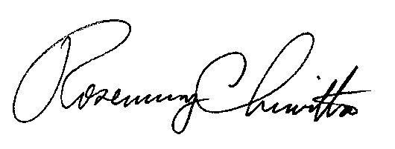
Sincerely,

Rosemary Chiavetta
Secretary
Enclosure

RC:AEL

