 | COMMONWEALTH OF PENNSYLVANIA  PENNSYLVANIA PUBLIC UTILITY COMMISSION  COMMONWEALTH KEYSTONE BUILDING  400 NORTH STREET  HARRISBURG, PENNSYLVANIA 17120 | IN REPLY PLEASE REFER TO OUR FILE

June 30, 2023

Service by Email and Postal Service

SHAWN JEFREMOW, PRESIDENT
NATURES CURRENT LLC
501 CAMBRIA AVENUE, SUITE 389
BENSALEM, PA 19020
Email: shawnj@naturescurrent.com

Dear Sir:

On June 24, 2023, the Commission received a corrected Application, a new CD – rom regarding the Application, and the Pennsylvania Depart of State Form regarding the Application of Natures Current LLC for approval to supply natural gas services to the public in the Commonwealth of PA. Upon review, the Application has been determined to still be deficient for the following reasons:

- The Application is outdated. Your Application must be based on the latest version of the template, accessible in the application packet on our website. (In other words, the revised version date on the application form must be listed as “4/13/23” and not “3/10/16”.)

- No original signatures.

- The Legal Name “Natures Current LLC” has been listed incorrectly throughout each proof of publication. Your Legal Name cannot be listed as “Natures Current”. “Natures Current LLC” must be inserted throughout each proof of publication exactly as it appears on your Pennsylvania Department of State Corporation Bureau website.

- No Certificate of Service.

- The new CD – rom copy of the Application includes both license applications for electric generation services and natural gas services. The license applications for electric generation services and natural gas services must be on two separate CD – roms. Please make two separate CD – rom copies for the license application for natural gas services if the CD – rom copy includes both public and confidential information.

Pursuant to 52 Pa. Code §1.4, you are being advised of these deficiencies and are required to file corrections. Failure to correct the foregoing missing information within 20 days of the date of this letter will result in the Application being returned unfiled.
Please return your items to the above listed address and address to the attention of the Office of the Secretary.

If you have any question in regards to this letter, please contact our bureau at (717) 772-7777. Thank you
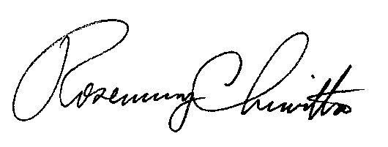
Sincerely,

Rosemary Chiavetta
Secretary
Enclosure

RC:AEL

