 | COMMONWEALTH OF PENNSYLVANIA  PENNSYLVANIA PUBLIC UTILITY COMMISSION  COMMONWEALTH KEYSTONE BUILDING  400 NORTH STREET  HARRISBURG, PENNSYLVANIA 17120 | IN REPLY PLEASE  REFER TO OUR FILE

August 2, 2023

A-2023-3041670 & A-2023-3041679

TO ALL PARTIES OF RECORD

A-2023-3041670: Application of the Department of Transportation of the Commonwealth of Pennsylvania for approval to alter the public crossing (DOT 517 668 X) by the installation of new warning devices and crossing surface, where Center Street (T-343) crosses, at grade, a track of East Penn Railroad LLC, in New Garden Township, Chester County all in accordance with the Federal Grade Crossing Program Garde Crossing Program and the allocation of cost incidental thereto.
A-2023-3041679: Application of the Department of Transportation of the Commonwealth of Pennsylvania for approval to alter the public crossing (DOT 517 768 C) by the installation of new railroad warning devices and crossing surface where Reese Street (T-445) crosses, at grade, a track of East Penn Railroad LLC, in New Garden Township, Chester County all in accordance with the Federal Grade Crossing Program and the allocation of costs incident thereto.

To Whom It May Concern:

This is to advise that a PUC field investigation will be held at the subject crossings on Thursday August 10, 2023, at 10:00 am to discuss the subject applications.
We will first convene at the crossing on Center Street beside 155 Center St, Toughkenamon.

Kindly arrange to have a representative present.

Very truly yours,
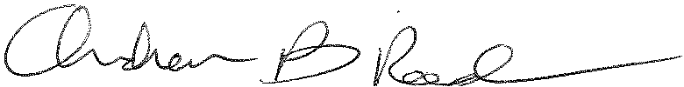
Andrew Reed, P.E.
Transportation Division - Rail Section
Bureau of Technical Utility Services
Phone (717) 787-4510
Email andreed@.pa.gov

