 | COMMONWEALTH OF PENNSYLVANIA  PENNSYLVANIA PUBLIC UTILITY COMMISSION  COMMONWEALTH KEYSTONE BUILDING  400 NORTH STREET  HARRISBURG, PENNSYLVANIA 17120 | IN REPLY PLEASE REFER TO OUR FILE

July 20, 2023

Service by Email and Postal Service

ANDREW BAKEY
D/B/A BAKEY ENERGY CONSULTING
900 NORTH 9TH STREET, SUITE, 628
PHILADELPHIA, PA 19123
Email: abakey@comcast.net

Dear Sir:

On June 29, 2023, the Commission received the Application of Andrew Bakey d/b/a Bakey Energy Consulting for approval to supply natural gas services to the public in the Commonwealth of PA. Upon initial review, the Application has been determined to be deficient for the following reason:

- An original signature is required on the Certificate of Service.

Pursuant to 52 Pa. Code §1.4, you are being advised of this deficiency and are required to file a correction. Failure to correct the foregoing missing information within 20 days of the date of this letter will result in the Application being returned unfiled.
Please return your item to the above listed address and address to the attention of the Office of the Secretary.
If you have any question in regards to this letter, please contact our bureau at (717) 772-7777. Thank you
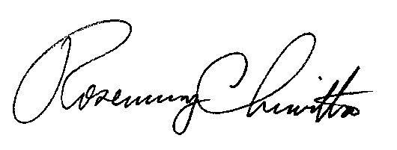
Sincerely,

Rosemary Chiavetta
Secretary
Enclosure

RC:AEL

