 | COMMONWEALTH OF PENNSYLVANIA  PENNSYLVANIA PUBLIC UTILITY COMMISSION  COMMONWEALTH KEYSTONE BUILDING  400 NORTH STREET  HARRISBURG, PENNSYLVANIA 17120 | IN REPLY PLEASE REFER TO OUR FILE

July 13, 2023

Via E-mail: millcreektruckingllc@gmail.com
SHANIA AND ELIOTT PASQUARETTE
MILLCREEK TRUCKING LLC
122 JONES MILLS STAHLSTOWN RD
JONES MILLS PA 15646

Dear Sir/Madam:

On June 29, 2023, the Commission received your Application for Motor Common Carrier of Property of Millcreek Trucking, LLC. Upon initial review, the Application is missing the following items needed in order to accept it as a filing.

- $100.00 filing fee must be in the form of a certified check or money order (as stated in the application instructions). Personal and checks drawn from a Corporate account are not accepted.

Pursuant to 52 Pa. Code §1.4, you are required to correct these items. Failure to do so within 20 days of the date of this letter will result in the Application being returned unfiled.
Please return your items to the above listed address and address to the attention of Amanda Clouser, Legal Assistant II no later than August 2, 2023.

Should you have any questions pertaining to your application, please contact our Bureau at 717-772-7777.

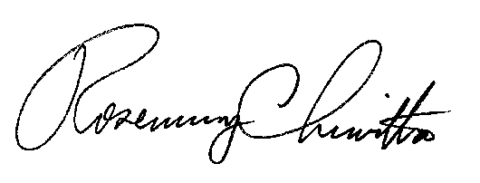
Sincerely,

Rosemary Chiavetta
Secretary

RC:anc

Enclosure: $100.00 Company Check # 112

