 | COMMONWEALTH OF PENNSYLVANIA  PENNSYLVANIA PUBLIC UTILITY COMMISSION  COMMONWEALTH KEYSTONE BUILDING  400 NORTH STREET  HARRISBURG, PENNSYLVANIA 17120 | IN REPLY PLEASE REFER TO OUR FILE

IN REPLY PLEASE
REFER TO OUR FILE
Secretary
717-772-7777
August 10, 2023

A-2023-3042138

Service by EService

EMILY M. FARAH, ESQUIRE
DUQUESNE LIGHT COMPANY
411 SEVENTH AVENUE
MAIL DROP 15-7
PITTSBURGH, PA 15601
Email: efarah@duqlight.com

Dear Ms. Farah:

Receipt is acknowledged of the Letter of Notification of Duquesne Light Company, which has been captioned and docketed to the above number.

This matter will receive the attention of the Commission and you will be advised of any further necessary procedure.

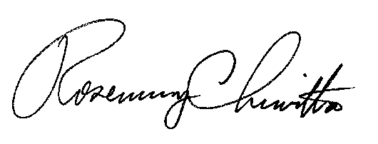
Sincerely,

Rosemary Chiavetta
Secretary

RC:AEL

