 | COMMONWEALTH OF PENNSYLVANIA  PENNSYLVANIA PUBLIC UTILITY COMMISSION  COMMONWEALTH KEYSTONE BUILDING  400 NORTH STREET  HARRISBURG, PENNSYLVANIA 17120 | IN REPLY PLEASE REFER TO OUR FILE

August 16, 2023

Via e-mail: leaderwarriorjones@gmail.com
NICOLE JONES
LITTLE RED RIDING HOOD INC
2216 BROADWAY AVE
PITTSBURGH PA 15218

Dear Ms. Jones:

On August 7, 2023, the Commission received your Application for Motor Common Carrier of Persons in Experimental Service of Little Red Riding Hood, Inc. Upon initial review, the Application is missing the following items needed in order to accept it as a filing.

- Page 4 of application was left completely blank. Please print your name, provide your signature and the date.

Pursuant to 52 Pa. Code §1.4, you are required to correct these items. Failure to do so within 20 days of the date of this letter will result in the Application being returned unfiled.
Please return your items to the above listed address and address to the attention of Amanda Clouser, Legal Assistant II no later than September 5, 2023.

Should you have any questions pertaining to your application, please contact our Bureau at 717-772-7777.

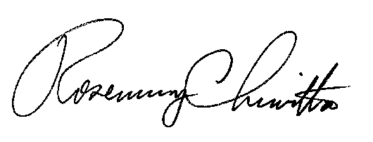
Sincerely,

Rosemary Chiavetta
Secretary

RC:anc

cc: Jason Kelley, Esq.

