BEFORE THE
PENNSYLVANIA PUBLIC UTILITY COMMISSION

Melanie S. Kokenda :
:
v. : C-2023-3038774 :
West Penn Power Company :

INTERIM ORDER
CLOSING THE RECORD

AND NOW, the transcript of the July 12, 2023, hearing in this case having been received by the Commission’s Secretary’s Bureau in Harrisburg on August 3, 2023; and a copy of the transcript having been received by me in the Commission’s Office of Administrative Law Judge in Pittsburgh on August 11, 2023; and no further hearings in this matter are to be scheduled or held,

THEREFORE,

IT IS ORDERED:

- That the record at Docket No. C-2023-3038774 is hereby closed as of August 11, 2023.

2. That the Initial Decision in this case shall be prepared and issued.

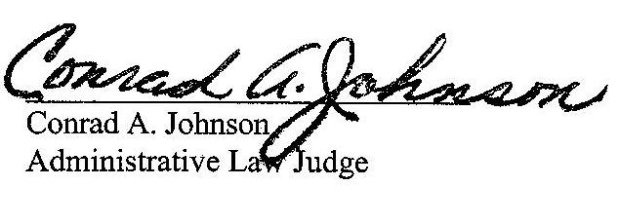
Dated: September 14, 2023

C-2023-3038774 - MELANIE S. KOKENDA v. WEST PENN POWER COMPANY
MELANIE S KOKENDA

MARGARET MORRIS ESQUIRE
REGER RIZZO & DARNALL
CIRA CENTRE 13TH FLOOR
2929 ARCH STREET
PHILADELPHIA PA 19104
215.495.6524
mmorris@regerlaw.com
Accepts eService
Represents West Penn Power Company

