BEFORE THE
PENNSYLVANIA PUBLIC UTILITY COMMISSION

Leonardo Sanchez :
:
v. : F-2022-3037286 :
PECO Energy Company :

INTERIM ORDER
REOPENING THE RECORD FOR A FURTHER HEARING

AND NOW, on April 25, 2023, the hearing in this case convened and testimony was received from the parties; and testimony was not completed (Tr. 134-135); and on June 24, 2023, an interim order was entered inadvertently closing the record,

THEREFORE,

IT IS ORDERED:

- That the record at Docket No. F-2022-3037286 is hereby reopened.

2. That a further hearing shall be scheduled to complete the testimony in this case.

3. That the parties shall be notified in writing of the date and time of the further hearing.

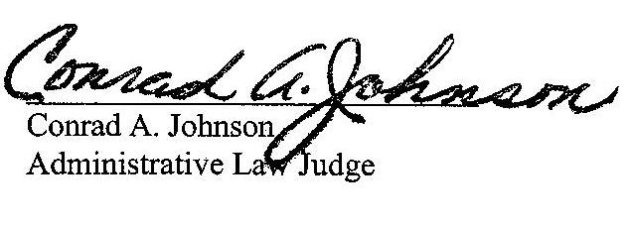
Dated: September 14, 2023

F-2022-3037286 - LEONARDO SANCHEZ v. PECO ENERGY COMPANY-ELECTRIC
LEONARDO SANCHEZ
109 CRUMP ROAD
EXTON PA 19341
267.972.7176
LEOANDVERO@GMAIL.COM
KHADIJAH SCOTT ASSOCIATE GENERAL COUNSEL
PECO ENERGY COMPANY
2301 MARKET ST
S23-1
PHILADELPHIA PA 19103
215.841.6841
KHADIJAH.SCOTT@EXELONCORP.COM
Accepts EService
PREDRAG FILIPOVIC, ESQ.
1635 MARKET STREET, STE.1610
PHILADELPHIA, PA 19103
267.265.0520
PFESQ@IFIGHT4JUSTICE.COM
Accepts eService

