 | COMMONWEALTH OF PENNSYLVANIA  PENNSYLVANIA PUBLIC UTILITY COMMISSION  COMMONWEALTH KEYSTONE BUILDING  400 NORTH STREET  HARRISBURG, PENNSYLVANIA 17120 | IN REPLY PLEASE REFER TO OUR FILE
October 2, 2023

Via Certified Mail

DON PATCH, MANAGING PARTNER
PATCH ENERGY SERVICES LLC
130 GARDENERS CIRCLE SUITE 603
JOHNS ISLAND SC 29455

RE: Bond Continuation
Patch Energy Services LLC
A-2011-2221397

Dear Mr. Patch:

Please find under cover of this letter the financial instrument filed with the Commission on behalf of Patch Energy Services LLC because it is not acceptable.

The Commission requires a supplier to file an original bond, letter of credit, continuation certificate, amendment, or other financial instrument as part of a supplier’s licensing requirements under Section 2809(c) of the Pennsylvania Public Utility Code.

The enclosed financial instrument does not have "wet ink" original signature for the Principal company

Please file the originally signed and sealed security instrument with my office within 20 days of the date of this letter, preferably by overnight delivery.

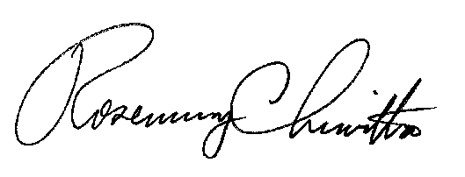
Sincerely,

Rosemary Chiavetta
Secretary of the Commission

RC:jbs

