BEFORE THE
PENNSYLVANIA PUBLIC UTILITY COMMISSION

Todd Elliott Koger :
:
v. : C-2023-3038703 :
Duquesne Light Company :

INTERIM ORDER
CLOSING THE RECORD

AND NOW, the transcript of the August 16, 2023, hearing in this case having been received by the Commission’s Secretary’s Bureau in Harrisburg on September 7, 2023; and a copy of the transcript having been received by me in the Commission’s Office of Administrative Law Judge in Pittsburgh on September 15, 2023; and no further hearings in this matter are to be scheduled or held,

THEREFORE,

IT IS ORDERED:

- That the record at Docket No. C-2023-3038703 is hereby closed as of September 15, 2023.

2. That the Initial Decision in this case shall be prepared and issued.

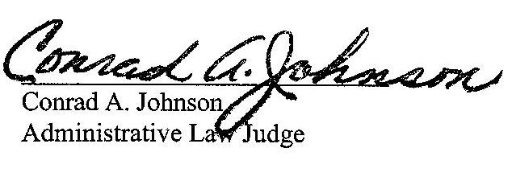
Dated: October 11, 2023

C-2023-3038703 - TODD ELLIOTT KOGER v. DUQUESNE LIGHT COMPANY
TODD KOGER
515 KELLY AVENUE
PITTSBURGH PA 15221
412.758.4510
kogerfriend@gmail.com
EMILY M FARAH COUNSEL
DUQUESNE LIGHT COMPANY
411 SEVENTH AVENUE
PITTSBURGH PA 15219
412.393.6431
efarah@duqlight.com
Accepts eService

