 | COMMONWEALTH OF PENNSYLVANIA  PENNSYLVANIA PUBLIC UTILITY COMMISSION  COMMONWEALTH KEYSTONE BUILDING  400 NORTH STREET  HARRISBURG, PENNSYLVANIA 17120 | IN REPLY PLEASE REFER TO OUR FILE

September 28, 2023

Via e-mail: agatruckingpa@gmail.com
GIL FIGUEROA PRESIDENT
AGA TRUCKING INC
5654 COLONY DR
BETHLEHEM PA 18017

Dear Mr. Figueroa:

On September 5, 2023, the Commission received your Application for Motor Common Carrier of Property of AGA Trucking, Inc. Upon initial review, the Application is missing the following items needed in order to accept it as a filing.

- $100.00 Filing Fee (Certified Check or Money Order only).

Pursuant to 52 Pa. Code §1.4, you are required to correct these items. Failure to do so within 20 days of the date of this letter will result in the Application being returned unfiled.
Please return your items to the above listed address and address to the attention of Amanda Clouser, Legal Assistant II no later than October 18, 2023.

Should you have any questions pertaining to your application, please contact our Bureau at 717-772-7777.

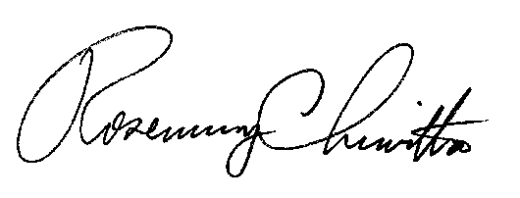
Sincerely,

Rosemary Chiavetta
Secretary

RC:anc

