BEFORE THE
PENNSYLVANIA PUBLIC UTILITY COMMISSION

Joseph Psut :
:
v. : C-2023-3041260
:
PECO Energy Company :

POST-HEARING ORDER #3

This Order is issued pursuant to the authority conveyed to presiding officers under the Commission’s regulations at 52 Pa. Code § 5.483.

On October 20, 2023, an Order (Post-Hearing Order #1) was issued at this docket re-opening the record in this matter and requiring the parties to provide specific information concerning each payment agreement or arrangement made by Joseph Psut (Mr. Psut or Complainant) relating to electric service provided by PECO Energy Company (PECO) no later than Friday, October 27, 2023. Pursuant to Post-Hearing Order #1, each party was instructed to express any object to any information provided by the other on or before Friday, November 3, 2023. Furthermore, Post-Hearing Order #1 informed the parties that a ruling on the admission into the record of information provided pursuant to Post-Hearing Order #1 would be reflected in the Initial Decision issued in this matter.

On October 25, 2023, PECO submitted via email to OALJ and the Complainant a document entitled Payment Agreement History describing two payment agreements entered into by Joseph Psut and PECO. A copy of Payment Agreement History supplied by PECO is attached hereto. To date, the Complainant has not submitted any information, nor has he objected to any of the information provided by PECO in the Payment Agreement History. PECO failed to label the supplemental information as an exhibit; nevertheless, the Payment Agreement History is hereby designated as proposed PECO Exhibit 5.

On October 31, 2023, an Order was issued (Post-Hearing Order #2) closing the record in this matter. Post-Hearing Order #2 should not have been issued prior to Friday, November 3, 2023, the date specified as the deadline for submitting objections to information provided pursuant to Post-Hearing Order #1. Although inadvertent, that error must be addressed and remedied.

To ensure that the Complainant has adequate opportunity to express any objection he may have to proposed PECO Exhibit 5, this Order re-opens the record for the purpose of allowing Mr. Psut additional time to express any objection he may have to the information contained in proposed PECO Exhibit 5.

Any objection must be expressed in writing and must be sent to the undersigned via email to the legal assistant, Pamela McNeal at pmcneal@pa.gov and to counsel for PECO via email to her at Khadijah.Scott@exeloncorp.com. Mr. Psut is directed to provide any such written objection on or before on or before November 30, 2023. Absent any objection communicated by Mr. Psut consistent with this Order, the record in this matter shall close without further action on December 1, 2023.

A ruling on the admission of proposed PECO Exhibit 5 into the record will be reflected in the Initial Decision issued in this matter.

THEREFORE,

IT IS ORDERED:

- That the record for Joseph Psut v. PECO Energy Company, Docket No. C-2023-3041260 is re-opened;.

- That the document entitled Payment Agreement History submitted by PECO on October 25, 2023 and attached hereto is designated as proposed PECO Exhibit 5;

- That Mr. Psut is granted until November 30, 2023 to express, consistent with this Order, any objection he may have to the Payment Agreement History submitted by PECO on October 25, 2023, attached hereto and identified as proposed PECO Exhibit 5; and

- Absent any objection communicated by Mr. Psut consistent with this Order, the record in this matter shall close without further action on December 1, 2023.

Date: November 15, 2023 /s/
Arlene Ashton
Administrative Law Judge

C-2023-3041260 - JOSEPH PSUT v. PECO ENERGY COMPANY-ELECTRIC

JOSEPH M PSUT
3272 WEBB ST
PHILADELPHIA PA 19134
1.215.941.0133
kma_824@yahoo.com
Accepts eService

KHADIJAH SCOTT ESQUIRE
PECO ENERGY COMPANY
2301 MARKET STREET - S23-1
PHILADELPHIA PA 19103
267.533.1830
Khadijah.Scott@exeloncorp.com
Accepts eService
(Counsel for PECO)

PROPOSED
PECO EXHIBIT 5

PAYMENT AGREEMENT HISTORY

Name JOE PSUT
Address 3272 WEBB ST PHILADELPHIA PA 19134
Account Number 90213-67090
Case Number C-2022-3035383

PECO AGREEMENT (NOT A PUC AGREEMENT)
AGREEMENT START DATE: 8/17/21
COMPLAINANT REPORTED MONTHLY GROSS INCOME: $614.00 with 1 adult; which is 57% of the Federal Poverty Level (FPL).
AGREEMENT AMOUNT: 13,285.27
NUMBER OF INSTALLMENTS: 60
INSTALLMENT AMOUNT: $221.42
FINAL INSTALLMENT: $221.49
CAP ARREARS INCLUDED IN OUTSTANDING BALANCE: $5,810.72
LAST AGREEMENT DEFAULT DATE: 1/10/22
AMOUNT OF BALANCE ON DATE OF DEFAULT: $12,842.43
PAYMENTS MADE BETWEEN AGREEMENT START DATE AND DEFAULT DATE: $535.56
REINSTATEMENT AMOUNT (as of 10/24/23) - $4,607.25 (subject to change)
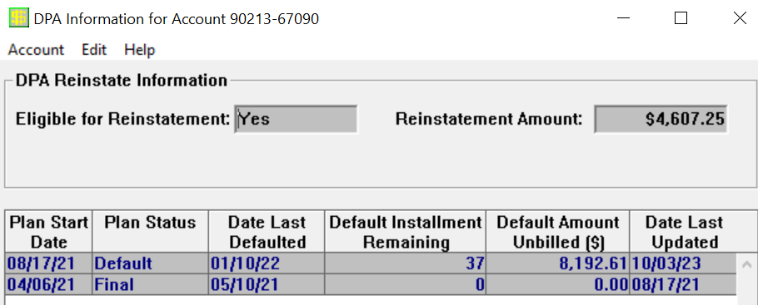

PECO AGREEMENT (NOT A PUC AGREEMENT)
AGREEMENT START DATE: 4/06/21
COMPLAINANT REPORTED MONTHLY GROSS INCOME: $614.00 with 1 adult; which is 57% of the Federal Poverty Level (FPL).
AGREEMENT AMOUNT: $13,170.92
NUMBER OF INSTALLMENTS: 24
INSTALLMENT AMOUNT: $548.79
FINAL INSTALLMENT: $548.75
LAST AGREEMENT DEFAULT DATE: 5/10/21
AMOUNT OF BALANCE ON DATE OF DEFAULT: $13,207.86
PAYMENTS MADE BETWEEN AGREEMENT START DATE AND DEFAULT DATE: $0.00

Consistent with Commission policy, the Complainant’s address and account number have been redacted on the attachment. An unredacted copy was sent to OALJ and the Complainant on October 25, 2023.

